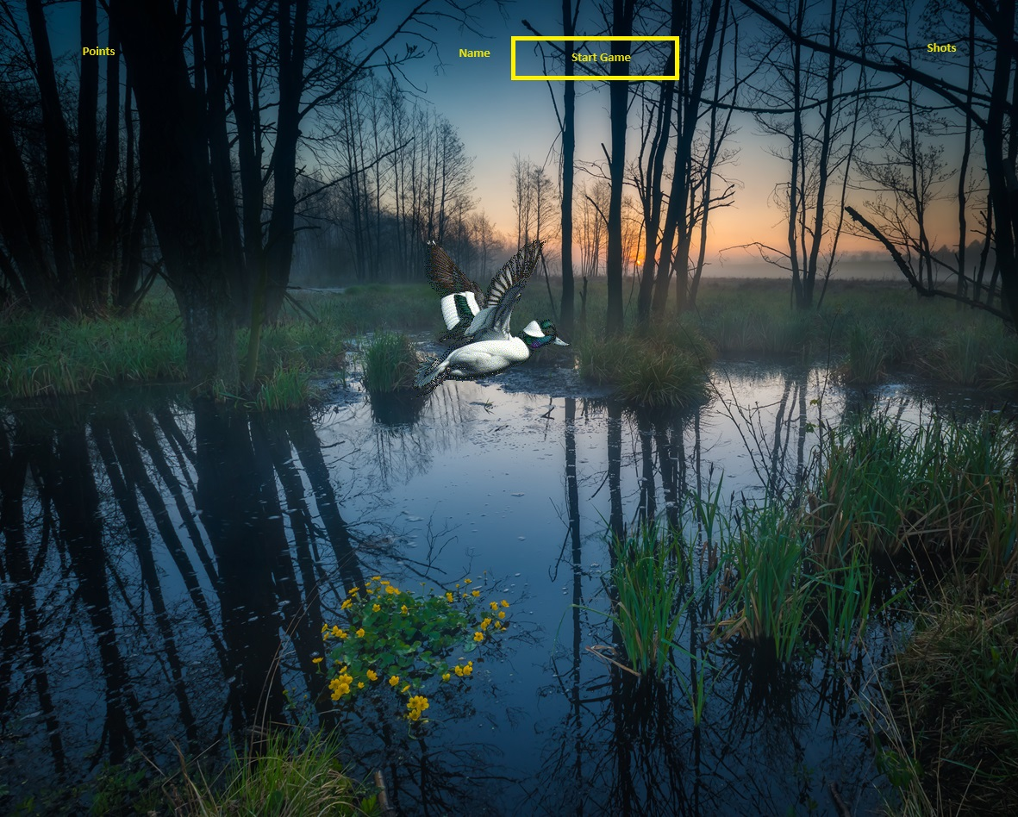

Duck Hunt

By: Shawn Nasseri

DGMD E-28 Developing Single- Page-Web Applications – Spring Term 2024 Project Proposal.

|  |
| --- |
| duck hunt game project purposal |

This project will have 2 phases. Phase 1 a react game were ducks fly and pass by and the user will use the mouse to put cross site on the duck and click to shoot them. Phase 2 if I have time will have unique duck species fly and pass.

|  |
| --- |
| details |

Phase 1. The user enters their name in a form window then clicks start game. Once the user does that then ducks start flying by. There will be a points box on the left and a shots box on the right showing points and shots. If user click is on the duck the game will make a gun sound and quack sound then bump the score by points allocated to the duck. Any time pressing ESC key ends the game and downloads the user’s name in a text file. I am thinking of a game component and a duck component in a duck’s array. Phase 2 the different duck species fly and pass with different points. Ducks that the season is closed on will cause a penalty to the user. The phase 2 duck’s array would be different species of ducks like mallard, pintail and so on. Pressing ESC will end the game and down load the file with user name and points scored.

A swamp background with ducks flying by. Phase 2 will have duck species like Mallard, Pintail, Red Head duck, Buffel Head and etc.… With different points and penalty for ducks that have season closed.



|  |
| --- |
| issues |

I am sure I can get Phase 1 done as that is before work travel. However Late April and early May I will be travelling to locations with bad internet and I figured if I turn everything with video in early, I will reduce the chance of not being able to login and send the project. Please let me know. Thank you.